**Article ID:** 1129 New b

**Article Name:** The rubber seal of my washing machine door is dirty.

**Topic Location:** Laundry / Washing machine / Cleaning & Maintenance

**Meta-data:** not clean, greasy, filthy, discolored, discoloured, gasket, sleeve

**Related Articles:**

**Related Questions:**

PNC

DIY

Safety

Link

Email

Book Engineer

Multimedia

Brand

**Article Content:**

Constant low temperature washing and the increasing use of liquid detergents (enzyme based) can cause mould and gelatinous dirt to build up in the door seal, pipes and drum. They can block up hoses, can cause a bad odour in the washing machine and may leave even deposits on your laundry.

**Cause**

This is usually a result of detergent residues and dirt. This can be caused by using too much detergent, or regular washing at a low temperature. If you only do washes at 40°C or below, there will eventually be a build up of residues from detergent and dirt in the washing machine. This can cause dirt, stains or grease on the seal.

**Solution**

Clean the seal with water or a normal household cleaning product or run a number of wash cycles at 95° C without laundry, but with a cup of sodium carbonate (Sodium carbonate irritates skin and mucous membranes. Please use it with extreme caution!) or a special washing machine cleaner like:

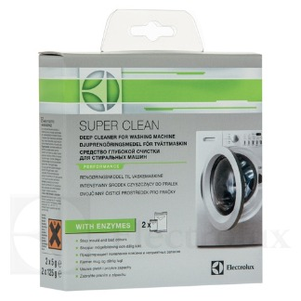

To buy this cleaner please follow the link to our webshop:

<http://shop.electrolux.co.uk/product/9029792786/Super-Clean+Washing+Machine+Cleaner>

This will clean the washing machine internally including the door seal.

**Prevention**

Clean your washing machine on a regular base by using sodium carbonate (Sodium carbonate irritates skin and mucous membranes. Please use it with extreme caution!) or a special washing machine cleaner like



To buy this cleaner please follow the link to our webshop:

<http://shop.electrolux.co.uk/product/9029792786/Super-Clean+Washing+Machine+Cleaner>